PRESS RELEASE

COMMUNICATIONS AND MEDIA TEAM OF THE 43rd ASEAN SUMMIT 2023

No.112/SP/TKM-ASEAN2023/ENG/9/2023

Indonesian President Welcomes Economic Revival at Indonesia-Papua New Guinea Border

Jakarta, 7 September 2023 - President of the Republic of Indonesia Joko “Jokowi” Widodo welcomes the economic revival at the Indonesia-Papua New Guinea (PNG) border following the opening of Skouw-Wutung border and direct flights from Denpasar to Port Moresby, the capital of PNG.

The Head of State made this statement during a bilateral meeting with the Prime Minister of Papua New Guinea (PNG) James Marape, held at the Kakatua Room, Jakarta Convention Center (JCC), Jakarta, on Thursday, 7 September 2023.

The meeting took place on the sidelines of the 43rd ASEAN Summit meetings, which concluded on Thursday, 7 September 2023, after commencing on 5 September 2023.
The President emphasized that these economic ties serve as an expression of appreciation for PNG's support for Indonesia's sovereignty and integrity, which was evident during the Melanesian Spearhead Group (MSG) Summit held in Port Vila, Vanuatu, from 23 – 24 August 2023.
"I highly appreciate Papua New Guinea's support for Indonesia's sovereignty and integrity, as demonstrated during the MSG Summit last month," President Jokowi stated.
Meanwhile, PM Marape expressed his compliment on Indonesia's successful chairmanship and hosting of the ASEAN Summit. He also declared his support for Indonesia as a close neighbor of PNG.
"I would like to congratulate you on the successful organization of the ASEAN Summit. Previously APEC and G20, now ASEAN and Papua New Guinea supports you. We are very proud of our closest neighbor," PM Marape stated.
On the final day of the 43rd ASEAN Summit, President Jokowi also held bilateral meetings with United Nations Secretary-General Antonio Guterres and Australian Prime Minister Anthony Albanese. Later in the afternoon, President Jokowi had a bilateral meeting with the Japanese Prime Minister Fumio Kishida.

***

For more information, please contact:

Director General of Public Information and Communications of the Ministry of Communications and Informatics – Usman Kansong (0816785320).

Get more information at http://asean2023.id, https://infopublik.id/kategori/asean-2023, and https://indonesia.go.id/kategori/ragam-asean-2023

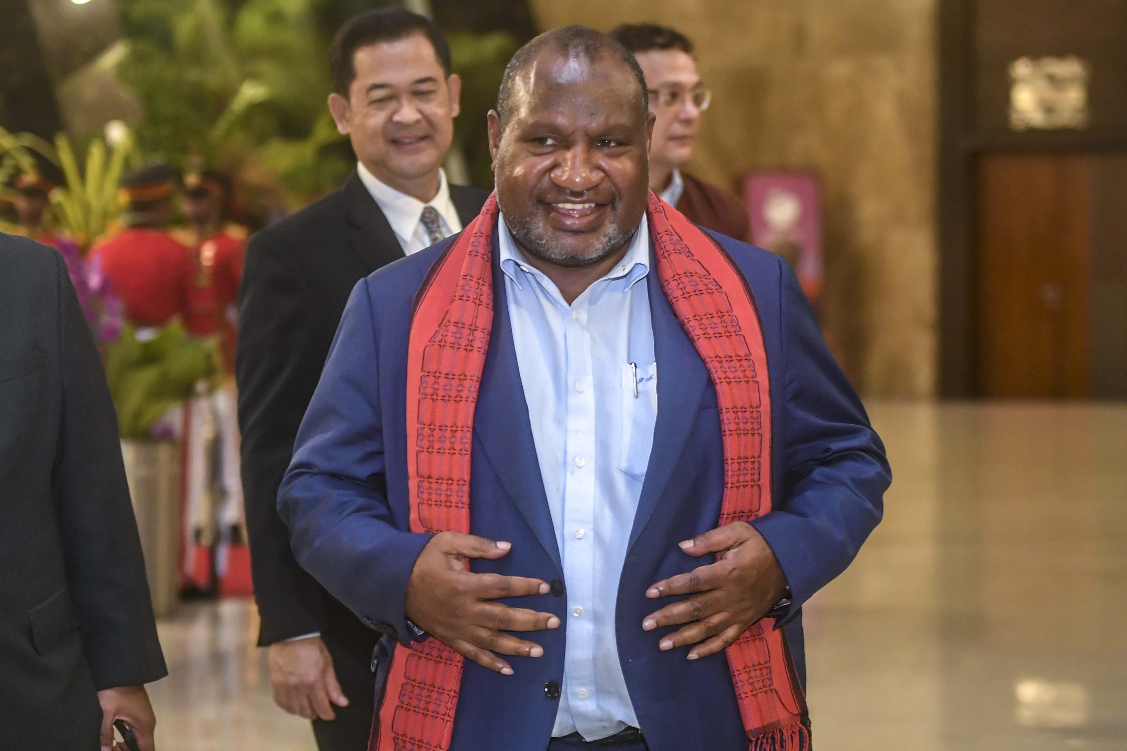

Prime Minister of Papua New Guinea James Marape walks upon arriving at the VVIP Terminal of Soekarno-Hatta International Airport, Tangerang, Banten, Wednesday (6/9/2023). ANTARA FOTO/Media Center KTT ASEAN 2023/Muhammad Adimaja/foc.

